TAJUK ARTIKEL

[Title: uppercase, Arial, font size 14, bold and entered]

(Title of Paper)

[Translation in English: Arial, font size 14, italic, bold, centered, bracket]

Author Name1*, Author Name2, Author Name3

[Use full name of all authors, Times New Roman, font size 10, superscript 1, 2, 3 etc. to indicate affiliation, bold and centered]

¹Faculty of Computer and Mathematical Sciences

²Faculty of Art and Design

Universiti Teknologi MARA (UiTM) Shah Alam

40450, Shah Alam, Selangor

[Indicate authors’ affiliation with superscript 1, 2, 3 etc. and start each address on new line, Times New Roman, font size 10, italic, centered, single line spacing paragraph]

*Corresponding author: email address [Times New Roman, font size 10]

ABSTRAK

[Abstract Heading: uppercase, Times New Roman, font size 11, bold, centered, single line spacing paragraph]

Template ini adalah format garis panduan bagi penulis yang menyediakan artikel atau makalah untuk disiarkan dalam Jurnal Inovasi Malaysia (JURIM). Pengarang mesti mengikut arahan yang diberikan dalam dokumen setiap artikel atau makalah yang akan disiarkan. Anda boleh menggunakan dokumen ini sebagai sampel set panduan penulisan dan sebagai templat ke dalam manuskrip anda dengan terma teks anda sendiri. Setiap manuskrip harus mempunyai abstrak, dalam lingkungan 150 hingga 250 perkataan yang memberikan gambaran keseluruhan berkenaan projek inovasi yang ingin diterbitkan.

[Abstract Body: Times New Roman, font size 11, italic, justified, single line spacing paragraph]

Kata kunci: [3-5 kata kunci, Times New Roman, saiz huruf 11 and santak kiri. Selang satu baris selepas abstrak]

ABSTRACT

This template gives formatting guidelines for authors preparing papers for publication in the Malaysia Journal of Analytical Science. The authors must follow the instructions given in the document for the papers to be published. You can use this document as both an instruction set and as a template into which you can type your own text. Each manuscript should have an abstract, within a range of 150 to 250 words that gives an overview of the project of the innovation that it wants to publish.

Keywords: [3-5 keywords, Times New Roman, font size 11 and text position left. Leave one blank line after abstract]

[Abstract words in Bahasa Malaysia and English. Use Times New Roman, italic 11-point font with text left and right justified and single spacing paragraph. Leave two blank lines before text of paper]

PENGENALAN (INTRODUCTION)

[All first order headings use Arial, font size 12, bold, unidented, single-line spacing]

This template gives formatting guidelines for authors preparing papers for publication in the Jurnal Inovasi Malaysia (JURIM). The authors must follow the instructions given in the document for the papers to be published. You can use this document as both an instruction set and as a template into which you can type your own text.

Introduction paragraph refers to problems or suggestions for improvement. You need to elaborate the problem statements and explain the solutions or suggestions for improvement.

[First paragraph of the text should be left and right justified, Times New Roman, font size 11, unindented and single spacing paragraph. The following paragraph is 0.5” indented to the right, double-line spacing before the next heading]

METODOLOGY (METHODOLOGY)

Sample [Second order headings should be bold, 11-point font and unindented, single-line spacing]

This template gives formatting guidelines for authors preparing papers for publication in the Jurnal Inovasi Malaysia (JURIM). The authors must follow the instructions given in the document for the papers to be published. You can use this document as both an instruction set and as a template into which you can type your own text.

Instruments

This template gives formatting guidelines for authors preparing papers for publication in the Jurnal Inovasi Malaysia (JURIM). The authors must follow the instructions given in the document for the papers to be published. You can use this document as both an instruction set and as a template into which you can type your own text.

KEBERHASILN PROJEK (PROJECT OUTCOMES)

This template gives formatting guidelines for authors preparing papers for publication in the Jurnal Inovasi Malaysia (JURIM). The authors must follow the instructions given in the document for the papers to be published. You can use this document as both an instruction set and as a template into which you can type your own text.

All illustrations including diagrams, charts and graphs must be labeled and provided in pages separate from text. The illustration position as required in the text should be clearly marked. All of these illustrations should be referred and numbered sequentially as a diagram.

All illustrations should be clearly illustrated. Images are in black or white color and are provided in the form of digital and camera-ready images (no less than 300dpi)

Table 1. [Table text and caption should centered, Times New Roman, font size 10, included in body text]
 | Title 2 | Title 3 | Title 4 | Title 5 | Title 6

Text A

Text B

Text C

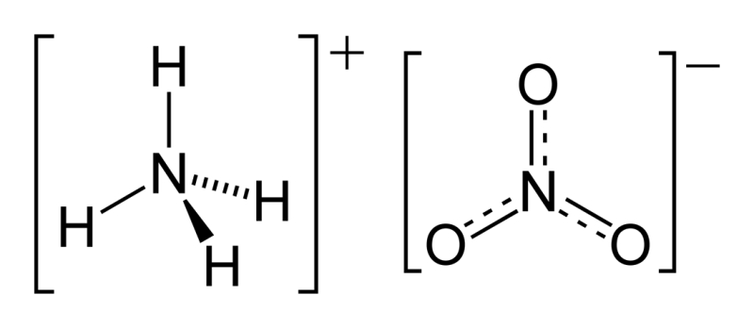

Figure 1. [illustration text and caption should centered, font size 10, included in body text]

KESIMPULAN (CONCLUSION)

This template gives formatting guidelines for authors preparing papers for publication in the Jurnal Inovasi Malaysia (JURIM). The authors must follow the instructions given in the document for the papers to be published. You can use this document as both an instruction set and as a template into which you can type your own text.

In this section there should be conclusions regarding the project or the briefly reviewed topic as well as suggestions for future improvements.

PENGHARGAAN (ACKNOWLEDGEMENT)

This template gives formatting guidelines for authors preparing papers for publication in the Jurnal Inovasi Malaysia (JURIM). The authors must follow the instructions given in the document for the papers to be published. You can use this document as both an instruction set and as a template into which you can type your own text.

Acknowledgement should be made to the parties involved directly and indirectly in the project described in this journal article. These include relevant parties in contributing to the success of the innovation project.

PRA-SYARAT (PRE-REQUISITE)

This template gives formatting guidelines for authors preparing papers for publication in the Jurnal Inovasi Malaysia (JURIM). The authors must follow the instructions given in the document for the papers to be published. You can use this document as both an instruction set and as a template into which you can type your own text.

Here is a list of participated innovation competitions related to the project or title of the manuscript. The prizes won should also be stated here.

[This should be included whenever appropriate as a separate section before Reference section, Times New Roman, font size 11]

RUJUKAN (REFERENCES)

[References should use the APA format (American Psychological Association). The reference style used should be consistent in all parts of the manuscript. Times New Roman, font size 11, first line unindented, the following line indented 0.5” to the right, left and right justified and single spacing paragraph with format:

Journal

Author, A. (Publication Year). Article title. Periodical Title, Volume(Issue), pp-pp. doi:XX.XXXXX or Retrieved from URL

Jameson, J. (2013). E-Leadership in higher education: The fifth “age” of educational technology research. British Journal of Educational Technology, 44(6), 889-915. doi: 10.1111/bjet.12103

Book

Author, A. (Year of Publication). Title of work. Publisher City, State: Publisher.

Finney, J. (1970). Time and again. New York, NY: Simon and Schuster.

Webpage

Author, A. (Year, Month Date of Publication). Article title. Retrieved from URL

Simmons, B. (2019, July 24). The Fourth Industrial Revolution (IR 4.0) and what it means for students like you. Retrieved from https://www.studymalaysia.com/education/top-stories/the-fourth-industrial-revolution-ir-4.0-and-what-it-means-for-students-like-you

